MODULE 4 & 5

MODULE 4

Reducing Hallucination in LLMs
Hallucinations happen when the model makes up facts or details that aren’t true, like inventing a historical event. It’s a common issue because models predict based on patterns, not perfect knowledge. Some strategies to combat hallucinations include:

4.1 ReAct (Reason + Act) Prompting
ReAct is a prompting framework where an LLM combines reasoning steps and external actions (like searching or tool use), allowing it to gather information, update plans, etc.
How it works: A simple repeating loop of Thought → Action → Observation → repeat until the answer is ready.
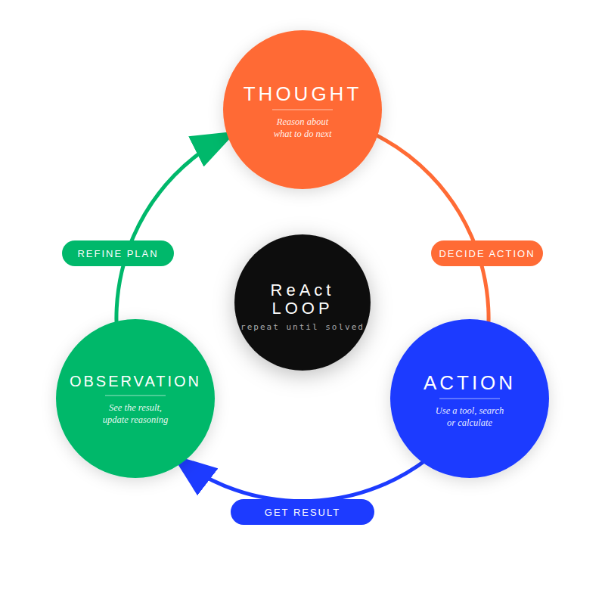
react_circular_loop2 (1).png

Example 1: Finding the Best Matching Product for a Customer Query
Prompt:
instruction: >
You are a smart shopping assistant. Use the ReAct reasoning format strictly.
format:
loop:
Thought: "Reason step by step about the query"
Action: "Take a specific action (e.g., search catalog, compare items, calculate discount)"
Observation: "Record the result of the action"
rule: "Repeat Thought → Action → Observation until the final answer is ready."
input:
customer_query: "<PUT_QUERY_HERE>"
output:
reasoning_trace: "ReAct steps"
final_answer: "Recommended product or response"
Input: “I need wireless earbuds under ₹2000 with good noise cancellation and at least 20 hours battery.”
Output:
Thought: Need to find earbuds under ₹2000 with noise cancellation and ≥20h battery.
Action: Search catalog for “wireless earbuds noise cancelling under ₹2000 20h battery”.
Observation: Found 3 models — Model X: ₹1799, ANC, 22h; Model Y: ₹1999, ANC, 18h; Model Z: ₹1499, no ANC.
Thought: Model X satisfies price (<₹2000), ANC present, and battery ≥20h.
Final output: Recommend Model X at ₹1799.

Example 2: Personalized Bundle Recommendation with Price Check
Prompt:
instruction: >
You are a bundling expert. Use a ReAct loop to create product bundles.
loop_format:
- Thought: "Reason about the bundling step"
- Action: "search_related_products(item) | calculate_bundle_price(items) | check_stock"
- Observation: "Result of the action"
rule: "Repeat Thought → Action → Observation until the bundle is finalized."
output:
reasoning_trace: "ReAct steps"
final_answer: "Bundle item and price"
Input: Customer just added smartphone (₹24999) to cart. Suggest a value bundle.
Output:
Thought: Smartphone buyer often needs protection + accessories.
Action: search_related_products(“smartphone accessories”)
Observation: Top: case ₹799, screen protector ₹499, charger ₹999.
Thought: Bundle case + protector = good protection, total add ₹1298.
Action: calculate_bundle_price([smartphone, case, protector])
Observation: Bundle price ₹26298 (5% discount).
Final output: Recommend “Protection Bundle”: case + screen protector for ₹26298 total.
When to use it: For tasks needing real-world info, tools, or interaction (search, calculators, APIs)—very powerful in agents or tool-using AIs.
Pros and Cons:
- Pros: Enhances interpretability and accuracy in interactive or knowledge-intensive tasks, handles exceptions well.
- Cons: Needs tool access (not plain chat); more complex to set up.

4.2 Chain-of-Verification (CoVe)
CoVe is a structured prompting method where the model first produces an answer, then deliberately verifies its own claims through targeted questions and revises the final response to reduce hallucinations and logical errors.
How it works:
The model generates an initial response, creates verification questions about its claims, answers them independently, and then revises the final answer using the verified facts.
Do you know? CoVe is like making the AI write an answer and then become its own strict teacher, it creates a checklist and fact-checks itself before finalizing!

Example 1: Aggregating Customer Review Highlights
Task: Summarize common pros/cons from reviews of smartphone.
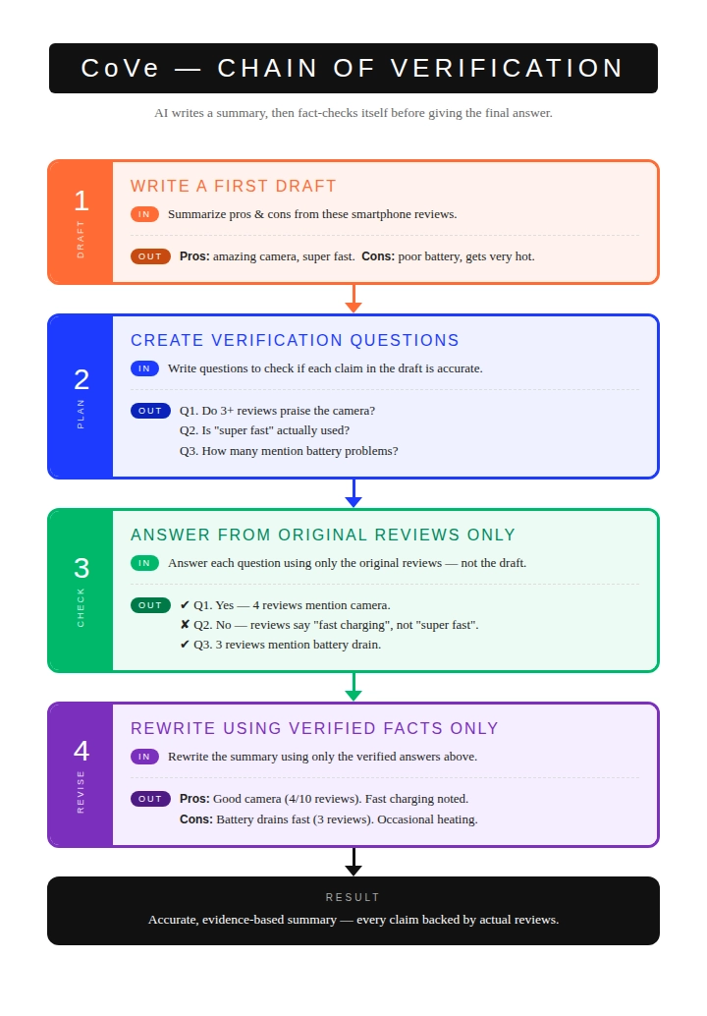
cove_concise.png

Example 2: Verifying a Product Feature Summary
Task: Summarize key features of a wireless earbud model accurately (no exaggeration).
CoVe Flow (multi-prompt):
- Draft Prompt: “Summarize the main features of XYZ wireless earbuds from the product specs: noise cancelling, 30-hour battery, IPX5 waterproof, deep bass.”
- (Draft: “XYZ earbuds offer top noise cancelling, incredible 40-hour battery, fully waterproof, and booming bass — best in class!”)
- Plan Verification Questions Prompt: “Given the draft summary above and original specs, generate 4 verification questions to check accuracy, completeness, and no exaggeration.”
- (Questions: 1. What is the actual battery life claimed? 2. Is “top noise cancelling” supported by specs? 3. What is the exact waterproof rating? 4. Does it say “best in class”?)
- Independent Answer Questions Prompt (one per question or batch): “Answer this verification question based only on original product specs: [question]”
- (Answers: 1. 30 hours. 2. No — specs say “active noise cancellation” but no “top”. 3. IPX5. 4. No such claim.)
- Revise Prompt: “Original draft: [draft]. Verification Q&A: [paste answers]. Revise the summary to be 100% factual and accurate.”
- (Final: “XYZ wireless earbuds feature active noise cancellation, 30-hour battery life, IPX5 water resistance, and deep bass sound.”)
When to use it: Best for hallucination-prone tasks such as multi-hop question answering (e.g., HotpotQA), fact extraction, list-based queries, or long-form content generation where deliberate self-verification identifies inconsistencies better than single-pass methods like CoT, ensuring higher factual accuracy.
Pros/Cons:
- Pros: Effectively reduces hallucinations and errors in complex, knowledge-intensive tasks by promoting self-correction; suitable for QA, verification, and generation needing coherence.
- Cons: Requires multiple steps, increasing latency and compute; not ideal for simple, factual queries or real-time applications where speed is prioritized over verification.

4.3 Chain-of-Note (CoN)
Chain-of-Note prompting improves retrieval-augmented language models by forcing them to explicitly evaluate, filter, and summarize retrieved documents into structured “notes,” helping the model ignore noisy or irrelevant information and correctly admit when knowledge is insufficient.
How it works: The model first converts retrieved documents into concise relevance-checked notes, then reasons only over those validated notes to produce an answer or decide “unknown.”
Do you know? When you give the AI lots of documents or search results, it often gets confused by junk. CoN forces it to read carefully, make short honest “notes”, and ignore the noise.Example 1: Answering Policy Question from Mixed Docs
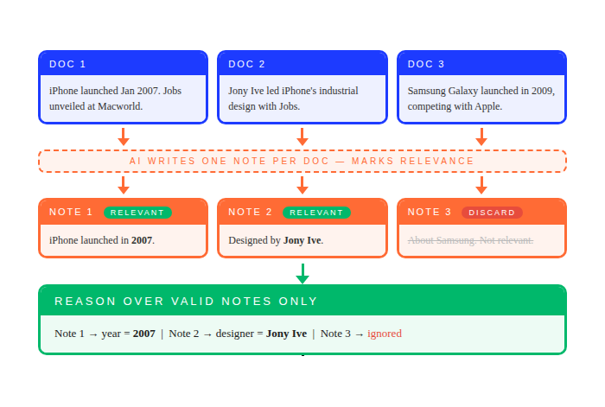
chain_of_note_partial.png
Prompt:
instruction: >
You are a policy Q&A agent. Use Chain-of-Note reasoning.
process:
- For each retrieved policy/document chunk, write a Note.
- Note fields: relevance to "return window for custom items", key rule, contradiction/noise.
- Chain reliable notes and ignore noisy or contradictory ones.
- Answer only using the reliable notes.
output:
notes: []
final_answer: ""
input:
query: "<PUT_QUERY_HERE>"
Input: “Can I return a custom-printed T-shirt?”
Retrieved:
Chunk 1: “Standard returns 15 days…”
Chunk 2: “Custom/personalized items non-returnable except defect.”
Chunk 3: “Sale items final sale.”
Chunk 4: “Free shipping over ₹999.”
Output:
Note of the chunks:
- Chunk 1: Not relevant (general 15-day return window).
- Chunk 2 : Relevant. Key rule: Custom/personalized items are non-returnable except for manufacturing defects.
- Chunk 3 : Not relevant (sale item rule).
- Chunk 4 : Noise (shipping policy).
Note utilized: Chunk 2
Final Answer : No, custom-printed T-shirts are non-returnable except for manufacturing defects.

Example 2: Product Recommendation with Catalog + Reviews
Prompt:
instruction: >
You are a recommender. Use Chain-of-Note reasoning.
process:
- For each retrieved chunk, write a short Note (relevant / irrelevant + key info).
- Ignore noisy or irrelevant chunks.
- Recommend only from reliable notes that satisfy the query.
input:
query: "<PUT_QUERY_HERE>"
retrieved_chunks: []
output_format:
notes: []
recommendation: ""
Input: Recommend budget noise-cancelling earbuds under ₹2500.
Retrieved chunks (mixed catalog + reviews):
Chunk 1: “Model A: ₹1999, ANC, 20h battery.”
Chunk 2: “Model B review: Best ANC under 3k!”
Chunk 3: “Old blog post about wired headphones…”
Chunk 4: “Model C: ₹2999, no ANC.”
Note of the chunks:
Chunk 1: Relevant, key specs.
Chunk 2: Relevant, positive sentiment for Model A/B range.
Chunk 3: Irrelevant (wired, old).
Chunk: Relevant but over budget + no ANC.
Output: “Model A at ₹1999 — solid ANC and battery, good reviews in budget range.”
When to use it: Ideal for open-domain question-answering tasks where retrieved documents may contain noise, irrelevance, or gaps, outperforming standard RALMs in scenarios like handling unverified web sources, fact-checking in real-time searches, or queries requiring rejection of unknowns, as it systematically filters for precision over naive integration.
Pros and Cons:
- Pros: Enhances robustness in noisy environments by improving exact match accuracy and rejection rates for out-of-scope questions.
- Cons: Increases response latency and token usage due to sequential note-taking, less efficient for clean or high-quality retrievals.

4.4 Chain-of-Knowledge (CoK)
This prompting method improves factual accuracy and complex reasoning by guiding the model to iteratively gather, verify, and integrate knowledge from multiple sources before producing an answer, reducing hallucinations compared to single-step reasoning.
How it works: The prompt forces the model to first frame the problem, then progressively retrieve and validate relevant knowledge from internal or external sources, and finally synthesize a grounded answer.
Do you know? This one makes the AI act like a detective — it collects facts piece by piece from different areas, connects them, then gives a super grounded answer.

Example 1: Deciding Dynamic Pricing for a Flash Sale
Prompt:
instruction: >
You are a pricing strategist. Use Chain-of-Knowledge reasoning.
Build the knowledge chain step-by-step, then give a recommendation.
chain_steps:
- Stock level and demand trend
- Average daily sales (no discount)
- Expected sales lift from discount
- Profit margin (full vs discounted)
- Competitor pricing
- Target customer segment
- Brand dilution risk
output_format:
knowledge_chain: []
recommendation: "Yes | No"
suggested_discount: ""
reasoning: ""
input:
question: "<PUT_QUESTION_HERE>"
Input: Should we run a 25% flash sale on wireless earbuds (normal ₹2499, cost ₹1499) for the next 24 hours?
Chain steps:
- Current stock level and trend.
- Average daily sales without discount.
- Expected sales lift from 25% discount (use typical e-commerce accessory benchmarks).
- Profit margin at full price vs discounted price.
- Competitor pricing for similar earbuds.
- Customer segment most likely to buy (age, behavior).
- Risk of devaluing the brand or training customers to wait for sales.
Now connect the chain and give final recommendation: Yes/No + percentage + reasoning.
Output:
Knowledge: High stock + strong lift expected + competitors already discounting
Output: Yes, but only 20% to protect margin.

Example 2: Should we approve an instant refund for a “not received” claim on a ₹12,999 order paid via UPI?
Prompt:
instruction: >
You are a risk decision agent. Use Chain-of-Knowledge reasoning.
Build knowledge step-by-step across domains, refine rationales,
then give the final decision.
process:
step_1_initial_rationales:
- Generate 2–3 preliminary hypotheses about the case.
step_2_identify_domains:
- Determine knowledge domains needed (tracking, payment risk, fraud signals, customer history, policy).
step_3_build_knowledge_chain:
- Insert verified facts from each domain.
step_4_refine_reasoning:
- Update rationales using the collected knowledge.
step_5_decision:
- Combine the knowledge chain to produce a final decision and action.
output_format:
rationales: []
knowledge_chain: []
conclusion: ""
action: ""
input:
case: "<PUT_CASE_DETAILS_HERE>"
Reasoning Preparation: Produce initial rationales -
- Rationale 1: “If tracking shows delivered, probably not a genuine non-delivery.”
- Rationale 2: “But UPI payments sometimes have fraud patterns.” Spot inconsistencies/gaps → identify needed domains: tracking data, payment method risk, delivery partner SLA, common fraud signals, customer history, policy rules.
Dynamic Knowledge Building: Generate and insert facts progressively from multiple domains.
- Domain 1 (Tracking & Logistics): Order ID: ORD98765 — tracking status = “Delivered” 2 days ago, proof-of-delivery photo shows package at gate, signed as received.
- Domain 2 (Payment Risk): Paid via UPI (instant, low chargeback protection compared to cards), new customer account created 3 days before order.
- Domain 3 (Customer History): First order, no previous returns or disputes.
- Domain 4 (Fraud Patterns): Common scam = claim “not received” after COD/UPI delivery with photo proof (~18% of such claims in last quarter were fraudulent per internal data).
- Domain 5 (Policy & SLA): Policy = investigate “not received” claims with proof required; refund only if confirmed lost/missing after 72-hour re-verification window with delivery partner.
- Domain 6 (Business Impact): Instant refund without check leads to high fraud exposure (₹12,999 risk). Delay and investigation leads possible negative review but protects revenue.
Answer Consolidation: Synthesize refined rationales -
“Strong delivery proof + new account + UPI + known fraud pattern outweighs lack of prior history means high fraud likelihood, so the policy requires investigation before refund.”
Output: Do not approve instant refund. Send polite messages asking customers to check with family/neighbor/guard (reference delivery photo), allow 72 hours for re-verification with delivery partner. If no update, escalate to full investigation/refund only if confirmed missing.
When to use it: Best for knowledge-intensive question-answering that span multiple domains and require high factual accuracy, outperforming traditional CoT by dynamically grounding responses in external heterogeneous sources to correct errors and reduce hallucinations.
Pros and Cons:
- Pros: Significantly improves factual reliability and reduces hallucinations in complex, knowledge-heavy tasks by integrating diverse sources, to minimise error.
- Cons: Adds computational overhead due to query generation and retrieval, unsuitable for simple factual questions.
Table 1: Overview of Popular Prompt Engineering Techniques
Technique | Simple explanation | How it works | Main goal | Things you might add to prompt
Zero-shot | Just ask — no examples | Give question only | Quick & simple tasks | (nothing extra)
Few-shot | Give 1–5 good examples before asking | Show → Answer format repeated a few times | When you want the model to copy a style | “Example 1: … → … Example 2: … → … Now do:”
Chain of Thought (CoT) | Tell the model: “think step by step” | Forces step-by-step reasoning before final answer | Math • Logic • Multi-step problems | “Let’s think step by step.”
Zero-shot CoT | Same as CoT but without any examples | Just add the magic sentence | When you don’t want to write examples | “Let’s think step by step.”
Auto-CoT / Auto-generated CoT | Let the model create its own examples automatically | LLM generates reasoning examples for itself | Save time writing few-shot examples | (done behind the scenes)
Self-Consistency | Ask the same question several times → pick most common answer | Run CoT many times + majority vote | Makes answers more reliable | (run prompt 5–10× and vote)
Tree of Thoughts (ToT) | Like CoT, but tries several different paths (like branches) | Explore → evaluate → pick best path | Hard planning / puzzle / strategy problems | “Explore 3 possible next steps, evaluate each…”
Graph of Thoughts (GoT) | Even more flexible than tree — thoughts can connect in any way | Thoughts can merge / loop / have multiple parents | Very complex reasoning | (usually needs special framework)
ReAct | Think + Act + Observe loop (like an agent) | Reason → take action (search/tool) → see result → repeat | Tasks that need internet / tools / real world | “Think → Action → Observation → repeat until done”
Chain-of-Verification (CoVe) | First answer → make checklist of facts → check & fix | Generate → verify → correct | Reduce hallucinations / wrong facts | “Generate answer → create verification questions → check”

Quick challenge for you:
Pick any one technique (I recommend starting with ReAct or CoVe) and test it right now with a real question like “Recommend earbuds under ₹2000”.

MODULE 5

Context Optimization Techniques
Large Language Models (LLMs) now support very large context windows (often 128k to 1M+ tokens in modern models from 2025–2026). However, real-world applications can still easily exceed these limits. Prompts may contain instructions, conversation history, examples, documents, and user inputs. When all of this information is included together, the total number of tokens can become too large.
Exceeding the token limit increases latency (response time), cost, and sometimes reduces model performance. Because of this, developers must manage how much information is included in the prompt.
Context optimization techniques help reduce the number of tokens while keeping the most important information for the task. The following sections explain common methods used to manage prompt context effectively in prompt engineering systems.

5.1 Naive Truncation
Naive truncation is the simplest and most commonly used method to ensure that a prompt fits within the model’s context window.
5.1.1 Removing extra tokens
In this approach, tokens are simply removed from the prompt when the total token count exceeds the allowed limit. Most LLM APIs use left truncation, which removes the oldest tokens first, such as earlier conversation messages or introductory content. This keeps the most recent user query and system instructions intact.
Some systems may use right truncation, which removes tokens from the end of the prompt. However, this is less common because recent information is usually more important.
Pros/Cons:
- Pros: Zero additional compute, trivial to implement, predictable token usage.
- Cons: Completely non-semantic—critical information can be discarded arbitrarily. This often causes hallucinations, factual errors, or loss of user intent.
5.1.2 Sliding window approach
A slightly better approach is the sliding window method, which keeps the most recent context while summarizing or preserving key information from earlier parts.
For long documents or multi-turn conversations, the system can:
- Extract relevant sections based on keywords or simple similarity checks
- Maintain a fixed-size buffer of the most recent conversation turns
- Optionally include a short summary of earlier interactions
Example pseudocode logic:

5.2 Retrieval-Based Selection
When working with external knowledge sources such as documents or databases, it is inefficient to include all available information in the prompt. Instead, retrieval-based methods select only the most relevant pieces of information.
In modern systems, retrieval, ranking, and optional compression are often combined before inserting information into the prompt.
A typical workflow might be:
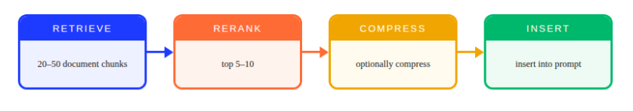
image.png
Note: Retrieval methods are a key part of Retrieval-Augmented Generation (RAG). In this module, we only introduce the basic concept. RAG will be covered in detail in a separate module.
Advanced retrieval systems use techniques such as:
- Maximal Marginal Relevance (MMR): Retrieve documents that are both relevant and diverse, avoiding redundant information.
- Contextual Compression Retrieval: Retrieve documents and compress them before sending them to the LLM.
- Hierarchical Retrieval: Retrieve information in multiple levels instead of directly loading many chunks.
These approaches can reduce prompt size while improving answer accuracy by removing irrelevant information.

5.3 Natural Language Compression
More advanced techniques reduce prompt size by rewriting or summarizing content while keeping its meaning intact. These approaches can often compress text 5–20× while maintaining useful information.
5.3.1 Prompt compression
Prompt compression techniques shorten prompts while attempting to maintain task performance.
Examples include methods such as LLMLingua and LongLLMLingua, which use smaller language models to identify and remove low-information tokens such as:
- Stopwords
- Redundant phrases
- Repeated formatting or boilerplate text
Another category, called soft prompts, replaces long text instructions with learned token embeddings.
5.3.2 Token optimization
Token optimization focuses on reducing unnecessary tokens in the prompt.
Common strategies include:
- Removing excessive formatting
- Merging repeated instructions
- Shortening descriptions without losing meaning
Some research methods estimate token importance using entropy or perplexity scores from smaller language models. This helps remove tokens that contribute little to the final output.
5.3.3 Semantic summarization
Semantic summarization uses an LLM to rewrite long content into a shorter, meaning-preserving summary that is relevant to the user’s query.
One recent method is ACON (Agent Context Optimization) introduced in 2025. It is designed for long-running AI systems that accumulate large amounts of context.
ACON works through an iterative improvement process:
- Start with a simple summarization instruction (for example, “Summarize key facts, decisions, and unresolved tasks”).
- Identify cases where the compressed context causes errors.
- Use a stronger LLM to analyze why compression failed.
- Improve the summarization guideline.
- Repeat the process until performance stabilizes.
Using this method, systems can compress context by 30–50% or more while maintaining about 95% of the original performance.

5.4 Dynamic Context Prompt Optimization (DCPO)
Dynamic Context Prompt Optimization adjusts the prompt during runtime as conversations or tasks progress.
5.4.1 Context rewriting
When a conversation becomes long (for example every 5–10 turns or when the token usage approaches 80% of the limit), the system can ask the model to rewrite the context.
The rewritten context may:
- Summarize previous conversation history
- Extract important entities and decisions
- Remove repeated or conflicting information
- Rewrite instructions more concisely
This keeps the prompt manageable while preserving important details.
5.4.2 Prompt refinement loops
Use reflection or self-critique: After generating an output, the model evaluates whether the response meets the determined criteria. If improvements are needed, the system adjusts the prompt or context before generating the next output. Some frameworks also compress reasoning traces over time so that the prompt remains small while the task continues.
5.4.3 Adaptive prompts
Adaptive prompting dynamically changes how prompts are constructed depending on the situation.
Examples include:
- Increasing or decreasing compression depending on the remaining token budget
- Injecting stored memory when needed
- Switching instruction style (detailed → concise) as the task becomes clearer
Some advanced agent frameworks also monitor token usage and automatically switch to summarized context or external storage when limits are approaching.

